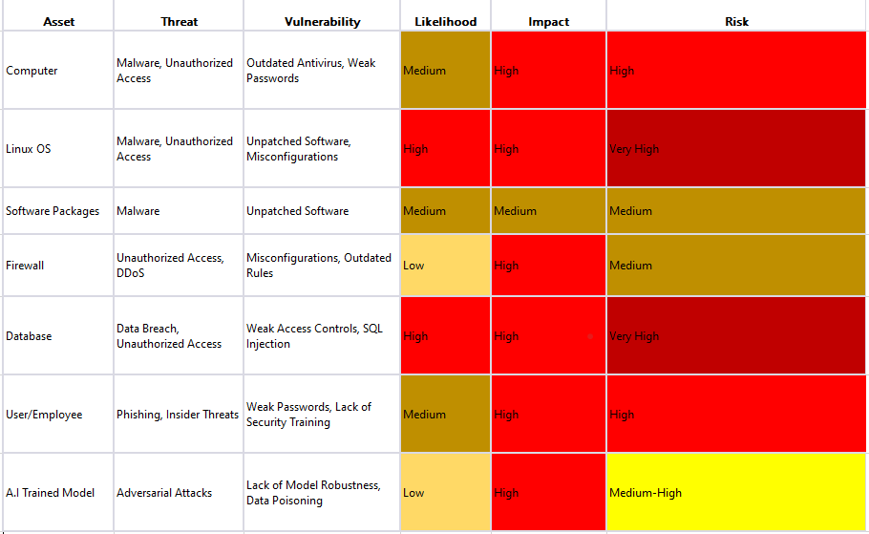
Likelihood: Low, Medium, High. Represents the probability of the threat exploiting the vulnerability.
Impact: Low, Medium, High. Describes the potential impact on the organization if the risk materializes.
Risk: Low, Medium, High. Combines likelihood and impact to provide an overall risk rating.

